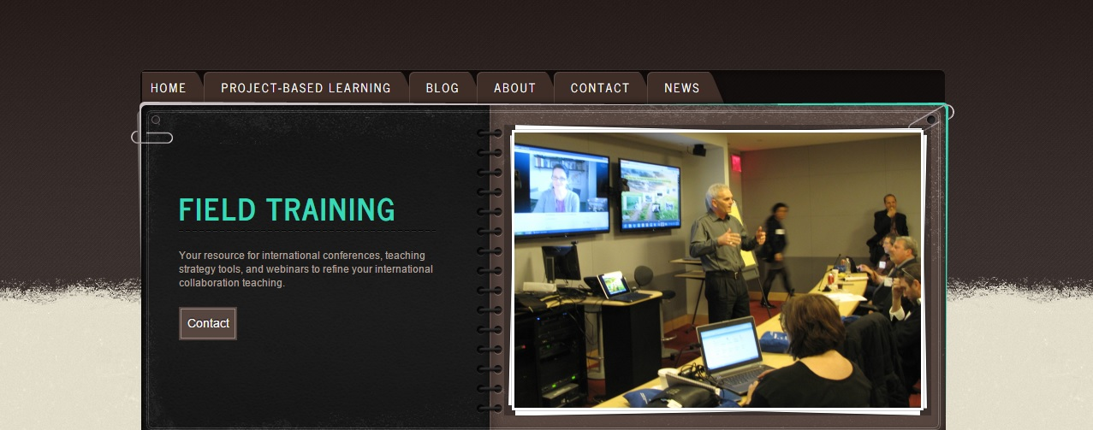
The Fabulous Four tips for creating powerful partnerships
Note: these same dynamics and solutions apply to your students interacting with their international peers too. So you will be modeling and learning how to do this well along with them).

- Get to know your partner personally. Just as it’s important that your students do this with their international peers, you do as well. Spend time texting, emailing and Skyping with each other in the first eight weeks so you understand who they are, the community, culture and family in which they live, likes and dislikes. In this way, you will come to understand their strengths, weaknesses, preferences and ways of working. This will help you use the strengths of your partnership to full advantage, avoid false assumptions that lead to miscommunication, and provide the glue to hold your partnership together when inevitable tensions arise during implementation.

- Pay attention to power dynamics. In my experience, those of us from the western world tend to play a leading role sometimes in setting a direction for the partnership, and those in the east will oftentimes tend to defer. Just as your students need to be aware of power dynamics, the faculty members do too. Being aware of this and talking about it openly helps to keep the relationship balanced and maximizing the strengths of everyone.

- Set up regular planning and debriefing meetings throughout the partnership. After you co-create your syllabus and begin work, adjustments inevitably are needed. It can be hard to have to spontaneously find time, across time zones, to figure out when you can meet. So set up a schedule ahead of time and meet virtually, even if it is brief. It will nurture your relationship and make adjustments significantly easier. Choose to videoconference more than text or email to avoid misunderstandings and build more of a head and heart connection.

- Establish a conflict resolution and problem-solving culture. Talk openly about how you want to deal with problems as they arise, discuss your own preferences for how to bring up and deal with issues and misunderstandings and cross-cultural errors.

